**An IOT based Personal Health card**

*A Thesis/Project Submitted in Partial Fulfillment of the Requirements for the*

*Degree of*

Bachelor of Science in Computer Science and Engineering

*by*

**Md. Humayun Kobir**

CSE06107313

&

**Rafid Tawhid**

CSE06107311

Supervised by: Ahmed Abdal Shafi Rasel

(Senior Lecturer)

|  |
| --- |
| C:\Users\Adnan\Desktop\1.jpg |

Department of Computer Science and Engineering

STAMFORD UNIVERSITY BANGLADESH

June 2020

**Abstract**

Abstract text here…

**Approval**

The project report “Thesis/Project Report name” submitted by STUDENTNAME ID: STUDENT_ID, STUDENTNAME ID: STUDENT_ID, to the Department of Computer Science & Engineering, has been accepted as satisfactory for the partial fulfillment of the requirements for the degree of Bachelor of Science (B.Sc.) in Computer Science & Engineering and as to its style and contents.

Board of Examiner’s Name, Signature and Date:

|  |  |  |
| --- | --- | --- |
| **……………………………...** | **……………………………..** | **……………………………..** |
|  |  |  |
| **(Board Member 1)** | **(Board Member 2)** | **(Board Member 3)** |
| Date: | Date: | Date: |

Supervisor’s Signature and Date:

**……………………………...**

**Supervisor Name**

Date:

**Declaration**

We, hereby, declare that the work presented in this Thesis / Project is the outcome of the investigation performed by us under the supervision of Supervisor Name, Supervisor Designation, Department of Computer Science \& Engineering, Stamford University Bangladesh. We also declare that no part of this Project and thereof has been or is being submitted elsewhere for the award of any degree or Diploma.

Signature and Date:

**……………………………...**

**Student Name:**

Date:

**……………………………...**

**Student Name:**

Date:

Dedicated to…

**Acknowledgements**

First and foremost, praises and thanks to the God, the Almighty, for His showers of blessings throughout our research work to complete the research successfully.

We are so grateful to **Md. Ahmed Shafi**, our supervisor, Senior lecturer in the Department of CSE, Stamford University Bangladesh, for giving us the opportunity to do research and providing invaluable guidance throughout this research. His insight and knowledge into the subject matter steered us through this research. We are extremly thankful and indebted to him for sharing expertise, and sincere and valuable guidance and encouragement extended to us. His dynamism, vision, sincerity and motivation have deeply inspired me. He has taught us the methodology to carry out the research and to present the research works as clearly as possible. It was a great privilege and honor to work and study under his guidance. We are extremely grateful for what he has offered us. We would also like to thank him for his friendship, empathy, and great sense of humor. We are extending our heartfelt thanks to his wife, family for their acceptance and patience during the discussion we had with him on research work and thesis preparation.

We take this opportunity to express gratitude to all of the Department faculty members of Stamford University Bangladesh for their help and support. And our biggest thanks to our family for all the support you have shown us through this research .Our sense of gratitude to one and all, who directly or indirectly, have lemt their hand in this venture.

**Table of Contents**

List of Figures 1

List of Tables 2

1: Introduction 3

1.1 Motivation 3

1.2 Sensors 3

1.2.1 Thermostats and HVAC controls 3

1.2.2 Example Figure: 4

1.2.3 Example Referencing 4

1.3 Chapter Summary 4

2: Literature Review 5

2.1 Background Study 5

2.1.1 Android Based Home Automation 5

2.2 Chapter Summary 5

3: System Design 6

3.1.1 Pin Definition 6

3.1 Parameter 6

3.2 Chapter Summary 8

4: Implementation 9

4.1 Implementation 9

4.1.1 Configuration Code 9

4.2 Chapter Summary 10

5: Conclusion 11

5.1 Limitations 11

5.2 Future Work 11

References 12

# List of Figures

1.1 NodeMCU Microcontroller 4

2.1: Android based Home Automation System 5

3.1: Pin Definition of NodeMCU 6

# List of Tables

3.1: Pin Description of NodeMCU 7

3.2: Parameters of NodeMCU 7

**Abstract-** Although the advancement of IoT and digital automation systems, there are many old system in our hospital management and communication we still follow manual patient registration and we don’t even have any special plan for emergency unfortunate road accident.

Though some substantial progress was made for improving the sharing of patient medical information among healthcare providers, professionals still need to address the issue of efficient electronic medical records

We thought about a plan which may help people with emergency medical treatment at any unwanted accident or disaster situations. Thus, real-time information presents a persistent challenge to the emergency response community. In emergency situations, particularly with unconsciousness. One can get basic emergency information easily of victim and follow the guidelines. Getting every possible information with root plan of nearby hospital and pharmacy may save the victims life. Hospital management system may digitalized with registration, treatment and records having the user-friendly system.

Another important problem we have that our doctors are not enough interested in using computers to treat patients. To overcome this problem, we have integrated the system into the Android app, which will be a lighter and more effective solution for the entire healthcare system and ensured to eliminate all physical constraints of hardcopy documents and to allow prompt access to medical charts or patient records.

As the present paper demonstrates, our major aim was to design an RFID-based real-time system application and databasel that would provide efficient means to perform essential information management for emergency care across hospital and country boundaries.

# Introduction

The present medical clinics are especially keen on expanding the quality and proficiency of persistent recognizable proof and observing methodology. While most patient health records are put away in isolated frameworks, there is as yet an enormous heap of desk work left for fill out in order to comply with different regulations. Since numerous human services mistakes happen at the point when significant patient data is missing or essentially not accessible, the electronic clinical records (EMRs) may handily lighten the misery of most specialists and attendants working in the present consideration framework. According to the traditional rules of our country, the patient has to stay in the hospital with a lot of paperwork, which is often more cumbersome for both the patient and the doctor. Occasionally the patient may have lost or misplaced necessary guidelines or laboratory reports, which can lead to extremely difficult situations.

In 1999, the Institute of Medicine (IOM) estimated approximately 98,000 deaths would occur each year in the US due to preventable medical errors, costing $37.6 billion [1], and becoming the sixth biggest killer in the US [2]. After five years, a study discharged by Health Grades [3] revealed a similar number of passing’s because of failure to improve patient safety. In 1996, thirteen distinctive health-card ventures with the clinical application were proposed in Germany (for example ONKOCARD - disease, DIABCARD - diabetes, PATIENTCARD - persistent history, electronic solution and so on.) [4].

Radio Frequency Identification (RFID) empowers programmed ID of items utilizing radio waves. The recognized items can be in and out of the view and there is no requirement for physical contact with them. RFID innovation is sent in a wide scope of ventures; for example, gracefully chain the executives, stock control, cultivating (to follow creatures), e-Passports, the following of people (in jails and medical clinics) and in medicinal services [5]. The three key components of a RFID framework are tags, readers and the backend server. Tags are gadgets genuinely connected to articles and readers (wired or versatile) perceive the nearness of items in its range. The server keeps up all the data about IDs for the tags and readers, their particular mysteries and any data about the item joined to the tag. A tag is normally comprised of a reception apparatus for getting and transmitting a radio-recurrence (RF) signal and an incorporated circuit for tweaking and demodulating the sign also, putting away and preparing data. There are three kinds of RFID Tags: active tags, semi-active tags and passive tags [6].

We propose to use an RFID based personal health card to store all vital health information related to restrictions in current health condition and drug administration, medications, allergies and sensitivities, current treatment, medical providers, and even contact people. The objective of this RFID-based individual medicinal services application is to empower simple and solid distinguishing proof arrangement of any patients in the event of crisis; it might keep up clinical records all the more precisely and digitalized the life in networks.

Basically, we have divided the system into three main infrastructures. First, is Data manipulated within the cloud database which is maintained by an authorized doctor as an admin role and able to add new patient, modified patient health condition records, lab reports, prescriptions, and personal information. Second is Authentication: which role will be played either doctor or reception in order to scan patient health cards and explore patient medical history. Finally Patient and Guest user: Patients able to explore their own health records by logging on by patient ID and password. Otherwise guest users able to explore patient health information by scanning the QR code of health-card and able to explore nearby emergency places within map route and direction.

However, patient data may not be available in some situations, either because the infrastructure is inaccessible or may be in an accident where there is no way to link the patient to the infrastructure (e.g. the patient cannot supply all necessary identification information).In that situation the patient could give the wrong diagnosis so that the patient may receive inappropriate treatment. In the case of an emergency situation in an accident injured or sick person, it is essential to obtain timely patient's past medical history in order to prevent the supply of incorrect treatments which could further aggravate the situation. The importance of having the medical history of patients is absolute to speed up the healing process and reduce many risk or health issues .Consider, for example, if a patient admitted urgently to a hospital and no one know or don’t have any reports of all the sensitive information needed before surgery, then he should be first subjected to a series of investigations and then go for surgery or other medical treatment. To overcome this problem, a QR code will be placed on the health-card, which will help anyone in case of emergency by scanning through the Android app outside the hospital about the patient and the history of treatment and able to explore nearby emergency place such as Hospital, ATM booth, Blood bank, Pharmacy, etc.

Another important problem is that doctors in our country are not interested in using computers to treat patients. To overcome this problem, we have integrated the system into the Android app, which will be a lighter and more effective solution for the entire healthcare system and ensured to eliminate all physical constraints of hardcopy documents and to allow prompt access to medical charts or patient records.

## Motivation

In our country on 2019, at least 198 people were killed and 347 others injured in 162 railway-related accidents.

In waterways, 64 people were killed, 157 others injured, and 110 went missing in 30 accidents, he added.

Over 50 percent of the people killed on roads were pedestrians. The highest, 2,013 accidents involved people being crushed under the wheels, a large number of drivers and their assistants were killed last year. At least 648 of the victims were on motorcycles. Buses and trucks were involved in 2,025 crashes while all other vehicles were involved in 2,677 crashes, June was the deadliest month followed by August with 379 crashes, he said.

The Eid holidays were in those months.

In that note we thought that it is not possible to reduce accidental death rate over night it may take time .but if we can ensure immediate proper treatment then death ratio could be slow down. We have an old version of hospital management system and most of our doctors , nurses and assistants are not aware of technological based First Aid system. So, we thought to build an user friendly easy app that one may have all the emergency health related information of patient in case of any accident by scanning a QR code through phone. It may faster the medical treatment, reduce the cost and mostly can reduce the death rate by giving proper treatment in time.

Today’s our medical sector has not taken full advantage from all the achievements of information systems now a days. Patient-related information is scattered among various medical units in a mess, the patients’ reposts and records have no centralized standard form and reports are seldom incomplete or not up-to-date. Moreover, if one need those health records in a hurry they cannot be accessed online. Another issue of healthcare system is related to supply chain and inventory management, such as, theft, counterfeiting, etc. Considering these major inconveniencies

In short our objectives are to reduce the previous testing load for the treatment details and the records. To develop a centralized and distributed app and database where the information is shared between doctor, patient or else. To provide assistance to patients at home when there is no one beside them or patience are in emergency. Everything will be record dynamically.

## System module

1. Microcontroller(WEMOS D1 mini esp8266)
2. RFID module(RC-522) with TAG
3. Power supply(5v ≈ 2A) with Micro-B USB Cable
4. Android emulator
5. Desktop GUI template

### WeMos D1 esp8266 microcontroller development board

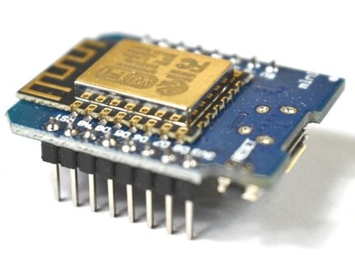

Figure 1.1 WeMos D1 mini ESP8266

Common functionalities and controls of the module are:

* WeMos D1 Mini is an inexpensive ESP8266-based WiFi board that is low-profile but just as powerful as any NodeMCU or ESP8266-based microcontroller.
* Can be controlled from local Wi-Fi network or from the internet (after port forwarding).
* The module can be programmed using an Arduino/USB-to-TTL converter through the serial pins (RX,TX).
* WiFi-enabled, and fully compatible with the Arduino platform.
* The D1 Mini will act as a web server, allowing any WiFi-connected device to interact with the board and control its pins wirelessly.
* It can do many of the things an Arduino board can do (analog input, digital input, I2C, etc.), but it can also handle WiFi communication.

### RFID module MFRC522

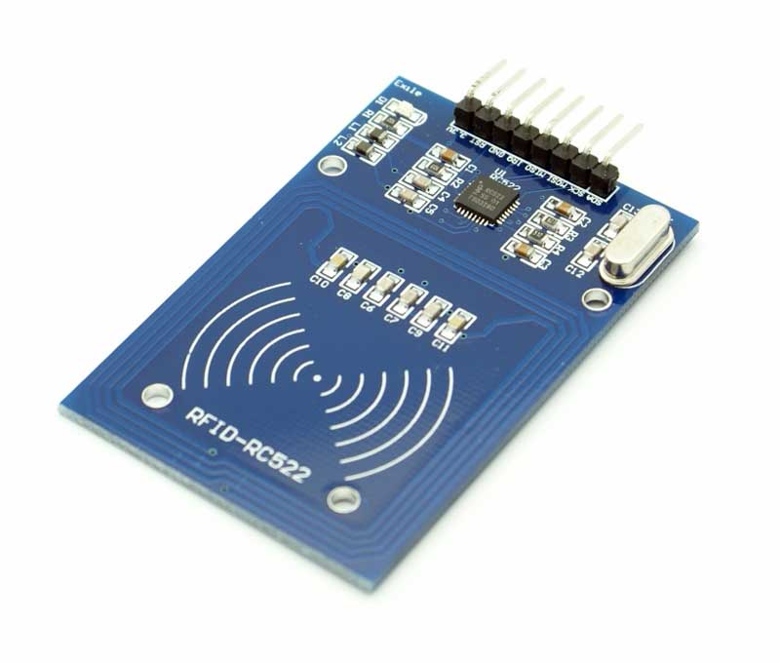

Figure 1.2 RFID MFRC522

Common functionalities and controls of the module are:

* It comprises of two main parts; the reader and the tags.
* The MFRC522 reader supports ISO/IEC 14443 A/MIFARE Mode.
* Highly-integrated reader/writer IC for contactless communication at 13.56MHz.
* Supports following interfaces: Serial Peripheral Interface, Serial UART and I2C_bus Interface
* This Module uses SPI as the interface to the external board.
* Max Data Transfer Rate:**10Mbit / s.**

## Chapter Summary

In this chapter, ....

# Literature Review

RFID innovation permits information to be remotely put away and automatically repossesses. It additionally gives a huge improvement over scanner tag innovation in recognizing, following, and loading objects. RFID developments have as of now been utilized in businesses like coordination’s [7] and assembling [8]. Human services has been figure to be the following home for RFID [9].

In the literature of RFID based health care and hospital management support various methods and tools have been studied & applied to automate and optimize the functionalities will be describe below.

## Background Study

**Belal Chowdhury, Rajiv Khosla (2007)[4]** presented RFID-based Hospital Real-time Patient Management System based on patient information electronically contained on RFID wristband this technology provides a method to transmit and receive data from a patient to health service provider/medical professionals without human intervention. intelligent systems can play a significant role in providing intelligently processed and personalized information about patients which had many benefits such as improve patients safety, eliminates paper-based document cost savings, increases efficiency and productivity but there have some demerits also like it could be job threaten to many people through cost saving for a company.

**Cristina TURCU, Cornel TURCU** proposed An RFID-based System for Emergency Health Care Services(2009)[1] where the vital information of the patient should be stored in a passive RFID tag, named Personal electronic record Identity Card (PIC). PIC card will store some data that serves as a reference to patient electronic health care record, located elsewhere on the network. Their advantage were Positive patient identification, Improving access to patient information, Accurate information on display and This information shall be secured against the editing and deletion by unauthorized personnel.

In the work of **STANLEY CHIA, ALI ZALZALA, LAURA ZALZALA, AND ALI KARIMI** Intelligent Technologies for Self-Sustaining, RFID-Based, Rural E-Health Systems(2013) [2] RFID-backed community healthcare solution was to enable easy and reliable identification of individual patients, maintain more accurate medical records. They used of “near field communications”, High-frequency RFID tags using 13.56 MHz are frequently used for very short range, high cost sensitive applications. Several incompatible standards exist for these including ISO/IEC 14443 type A and B, ISO 15693 and FeliCa standards. They had a unique Revenue sharing model between community healthcare worker and central medical facility.

RFID technology is classified as a wireless Automatic Identification and Data Capture (AIDC) technology that can be applied for the identification and tracking of entities. SIMOPAC is represented by the availability of vital medical information through patient cards and the usage of health information standards (such as HL7) to store, transfer and retrieve users’ health records.

Came out by the research of **CRISTINA TURCU, TUDOR CERLINCA, CORNEL TURCU, MARIUS CERLINCA, REMUS PRODAN** For every system that produces patient data, SIMOPAC will create an agent collecting data according with HL7 standard. This agent will be integrated in a multi-agent system thusthey found several advantage as like improve patient monitoring and safety; reduce the possibility of mother-baby mix-ups; increase asset utilization with real-time tracking, reduce medical errors by tracking medical devices , enhance the efficiency of supply-chain.

Various methods and tools have been studied to automate and optimise the functionalities and operations within hospitals. **Lina and Yang** (2008)[link] presented a three-layer electronic patient record management system that is expandable, maintainable, secure and cost-effective. Using various technologies, dataflow and activities at a hospital, function and operation analysis of the clinical departments in a hospital, the database structures have been designed by authors.

Three famous technologies: barcode, contact smart card, and contactless smart card offer the same services, identification and tracking; and database management flexibility which provides wide range detection & Mobility detection helps in detecting the patients without asking them to stop in front of the reader while their card is in their wallet. The technology that suited typical requirements was UHF RFID technology, and the appropriate product in the market chosen as a prototype to fit requirements was the Alien ALR 8800 RFID kit. This system was proposed by Qurban A. Memon & Shakeel A. Khoja(2012)[5].

Lash Mapa and Kishan Saha proposed a system, whereby they try to provide an RFID based patient management system more smartly within their recharge. The patient has been monitoring by a traditional wristband and the procedure of hospitalized, admission, waiting, nurse exam, waiting for doctor, doctor exam, etc process are defined within the RFID technology framework. However, they did not define any stage of emergency health services such as the critical situation of outpatients or how to handle patients.

An automated patient monitoring system remotely is presented by Padmapriya. Whereby their focus was monitoring patients (who are in Entirely bed) techniques in RFID technology to resolving issues such as Physical transcripts error, medical error trends, etc. They divided their system into two parts, monitoring, and tracking. The monitoring area includes the patient being given the RFID tag in the event that he/she is another patient; else the peruses the tag and his/her subtleties like special ID number, name, age, blood group, treatment details, the doctor attended in, past medical clinic visited and so forth toward the end the subtleties are refreshed in the login. The tracking segment includes the condition and the help gave to the patient when he/she is in a shut domain (home) when no one is around him/her. The patient on the bed is constantly checked by a temperature and heartbeat sensor. However, she did not mention management patients within the hospital and doctor prescribed case.

E. W. T. Ngai presented an RFID based healthcare management system, which would be more flexible for healthcare practices and the relevant industries. The system architecture has been consisting of five layers: data capturing front-end, data-capturing interface, processing modules, work-flow engine, and application layer. The first layer gives the RFID information catching front-end framework. It contains three parts: transponders, readers, and antennas. Second layer interface changes over the label data into information that is coherent in the framework parts in the upper levels, and the other way around. Finally, layers three, four, and five are mentioned to handle communication of the data from the patient to the institution then presented to the graphical interface accordingly. But unclear about doctor prescribed process and care about patients on emergency health medication environment from this system.

In the work of Cristina Turcu, Tudor Cerlinca, Marius Cerlinca and Remus Prodan a distributed RFID based system for patients’ identification and monitoring, named SIMOPAC has been developed. This framework empowers continuous distinguishing proof and observing of a patient in a clinical facility, on the base of CIP. A CIP is a passive RFID tag that is putting away important clinical data with respect to its bearer. The CIP gives snappy access to the real wellbeing condition of a patient and helps the clinical staff in taking the best choices, particularly in an instance of a crisis. Whereby individual electronic health card essential of patient recognizable proof. SIMOPAC CIPs are intended to store patient personal data, minimum general health data, just as other essential data fundamental in crisis circumstances. Which also ensured emergency medical information from patients to hospitals and family doctor correspondingly. User management, Tag management, etc are centralized by HL7 server.

Patrik Fuhrer and Dominique Guinard proposed a system to overcome traditional patient identification errors, inaccurate lab result error and improve productivity and administration by RFID based patient identification and tracking project. All patients admitted to the clinic are given an RFID-based wristband looking like a watch with a detached RFID chip. This chip stores a special patient ID number and some pertinent clinical data, for example, the patient's blood classification, so as to speed treatment. Their system also implemented smart operating theatres, anti counter fitting, Tracking Equipment, Patients, Staff and Documents, etc based on RFID technology and able to notifying doctor on his/her mistake and queries.

As of late, the Joint Commission on Accreditation of Healthcare Organization (JCAHO) called attention to the advancement of patient security upgrades as the primary objective of national patient wellbeing [rNote7]. The essential goal is to improve the precision of patient recognizable proof. The social insurance experts must be dynamic in enquiring understanding character, and in any event, two different ways must be utilized for quite recognizable proof.

Moreover, [an RFID based device for innovating the patients management](https://www.researchgate.net/publication/271314088_AN_RFID_BASED_DEVICE_FOR_INNOVATING_THE_PATIENTS_MANAGEMENT)[system researched by](https://www.researchgate.net/publication/271314088_AN_RFID_BASED_DEVICE_FOR_INNOVATING_THE_PATIENTS_MANAGEMENT) **[GIORGIO A[6]](https://www.researchgate.net/publication/271314088_AN_RFID_BASED_DEVICE_FOR_INNOVATING_THE_PATIENTS_MANAGEMENT)**[.Where the speed of data exchange with the effectiveness of a good RFID system with a trained up website which was built by visual studio on front-end for entry level information to store . This system can operate in a simple and efficient data flow (medical records, personal data) that is immediately available and always updated, providing a definite advantage for both the medical staff and patients.](https://www.researchgate.net/publication/271314088_AN_RFID_BASED_DEVICE_FOR_INNOVATING_THE_PATIENTS_MANAGEMENT)

Generally found OR mishaps incorporate wrong distinguishing proof of patients, careful destinations, and careful strategies. Furthermore, materials and instruments left inside the body after a medical procedure, sedation mistakes, inadvertent falls, and inappropriate medication organizations are likewise generally observed. Thomas et al. [rnote17] examined clinical blunders dependent on 15000 patient records. It was discovered that 83.8% of the clinical blunders happened in medical clinics. Among them, 39.5% were found in the working room.

**Cristina Turcu Cornel Turcu[8]** proposes a dual solution, a referential and a no referential approach. Thus, the considered card may also store some data that provide secure access to the patient’s electronic health care records kept in an electronic health record (EHR) system. This system enables real-time patient identification and monitoring, by employing the latest Radio Frequency Identification and multi-agent technologies. It ensures collaborative problem solving in distributed environment and provides communication infrastructure with multi-point connections to the medical information within the system. It extends patient identification across hospital boundaries, through the use of a specialized agent that implements specific information sharing protocol. Hence, the system can integrate with existing medical information systems. Moreover, the application running on RFID-enabled mobile devices gives healthcare providers the information and capabilities they need wherever and whenever they need them. Thus, this RFID-based software system is an open-loop RFID application that could function across hospital boundaries.

Focusing on reduce cost, and improve patient safety and medical services an application of RFID on the hospital has been proposed by Shang-Wei Wang. They also added that For the most part, the healthcare industry has been putting perpetually cash in information technology (IT) to decrease working expenses and improve understanding security and RFID is relied upon to get basic to medicinal services associations accomplishing these two objectives. 916.5 MHz UHF active tags were chosen to obtain real-time position-tracking as well as temperature taking abilities and monitoring abilities for tagged patients. This active tag was considerably more costly than passive ones; however, had a long understanding extent and better understanding velocity, empowering it to better constantly screen tagged people and items. Whereby patients also monitored by an embedded thermometer in order to obtain automatic temperature taking and transmission. Information was sifted by pre-set principles, before it was transmitted and put away in the situating database and fundamental data databases, individually. The framework consequently recovered patient clinical records from social insurance data frameworks and ran a derivation motor to judge whether there was an irresistible occasion such as precious equipment tracing, in-patient medicine auditing, new-born baby and mother identification, legitimate drug control, etc. However although this system would be a lightweight solution about admitted patients within the hospital, but it’s unclear about doctor prescribed process and care about patients on emergency health medication the environment both inside and outside the environment.

**PO-JEN CHEN** was suggesta system to solve Medical procedure related mistake, second to tranquilize related blunder, is one of the most regularly discovered clinical mistakes bringing about unexpected losses of patients. Improvement of activity room (OR) condition through effective OR the executives, careful methodology check, faculty correspondence, and data transmission can exceptionally lift quiet security using RFID. The goal of this framework was to coordinate remote systems and radio frequency identification (RFID) to plan an operation room management (ORM) framework by bringing in a rundown of clinical staff and building a data framework to ease remaining burden for the medicinal services suppliers in the working room, in this way empowering them to focus on tolerant considerations and medicines. It is valuable in supporting persistent and coordinated patient consideration administrations. By utilizing the programmed detecting and distinguishing proof parts

# System Design

1. This section describes the conceptual framework and the
2. methodology adopted for this work including the
3. systematically organized different stages of the research in
4. conjunction with the detailed implementation features of the
5. proposed system. In addition, it clarifies the structural
6. components of the proposed system and their integration to
7. achieve the research aim. The flowchart in Fig. 2 illustrates
8. the research stages followed in the present study.
9. This section describes the conceptual framework and the
10. methodology adopted for this work including the
11. systematically organized different stages of the research in
12. conjunction with the detailed implementation features of the
13. proposed system. In addition, it clarifies the structural
14. components of the proposed system and their integration to
15. achieve the research aim. The flowchart in Fig. 2 illustrates
16. the research stages followed in the present study.

**System design** is the phase that bridges the gap between problem domain and the existing system in a manageable way. This phase focuses on the solution domain, how to implement.

It is the phase where the SRS document is converted into a format that can be implemented and decides how the system will operate.

This section describes the conceptual design of our system and the methodology adopted for this work including the systematically organized different stages of the research in conjunction with the detailed implementation features of the proposed system. In addition, it clarifies the structural components of the proposed system and their integration to achieve the research aim.

In this phase, the complex activity of system development is divided into several smaller sub-activities, which coordinate with each other to achieve the main objective of system development.

### **System Overview**

As we have already mentioned, we have arranged the proposed system into three infrastructures. This is reflected in the figure below.

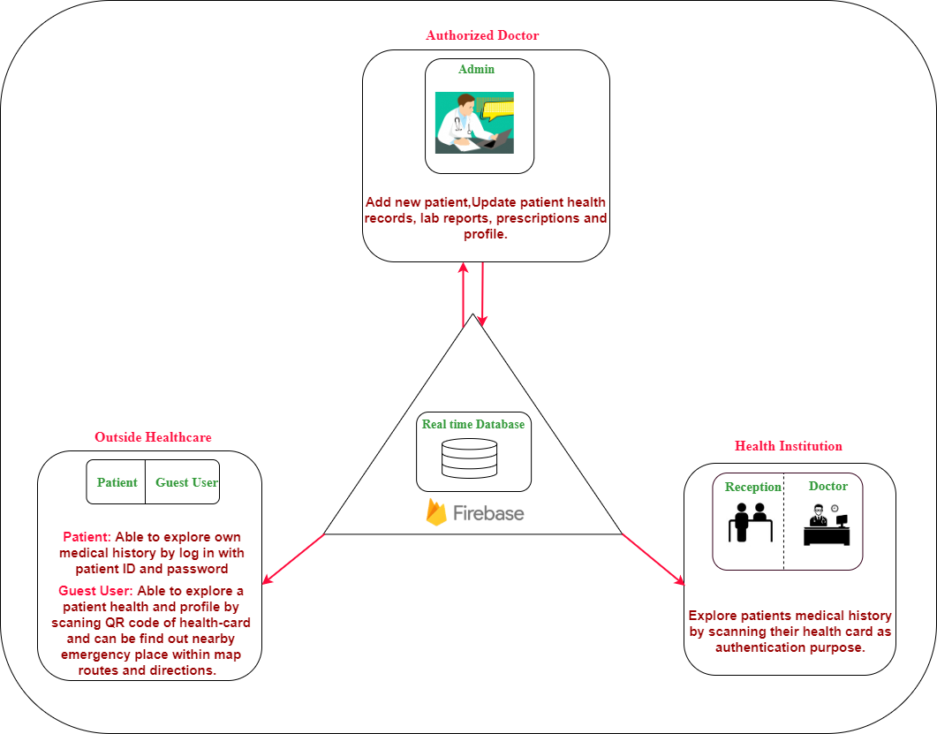

Figure 3.1.1: System Overview

If we explain our system overview when a doctor update a patient information it will save into our real time firebase database so one can get those information so fast when need.

In order to design our database system, it is considered that automated hospitals in a near-by location can collaborate with each other to share patient’s medical records because we have a real-time data processing system. All basic necessary information of patients medical records are being shared except patient’s financial and private information.

The previous hospitals, previous treatments, running medicines, health conditions, doctor’s information everything will be shared in reports.

In our database we care about

* Data Privency – only medical records and basic health condition are to be viewed no other sensitive personal information.
* Automated Database –collaboration of hospitals, doctors and diagnostic representative may update same database technology at a real time.
* Security of medical records – representative at local hospital and any gust user may have access to specified pages of one’s health record according to assigned privileges, whereas only doctor can update records from hospital personally.
* Control security- Only admin and developer have access in everything to upgrade the whole system for further betterment by the passage of time when necessary.

The final version of our personal health card application is implemented in some categories (admin, doctors/representative, patient, guest user)[fig-**]. In this paper we have described the fastest emergency treatment for a patient in an emergency situation. Each and every-one must hold a personal RFID card with a printed QR-code in its back. In emergency cases most of patients are unconscious or badly injured so in that case one can easily scanned his card and get all the specific emergency information from our real-time firebase database through his mobile. One can get all the nearby hospitals and pharmacies location with root info just in a second because here we use google-map API so patients could be hospitalized very fast. In hospital doctor could give the emergency treatment without having basic necessary test like (blood, diabetes, asthma, pressure, allergy) and if doctor prescribe any drug urgently one can easily find-out nearby pharmacy locations.

### **System Use Case Diagram**

### In this figure[Figure 3.1.2: System Use case] we clearly saw that admin or executive has the most access control he can easily add a new patient and update his info like health data, reports and prescription if necessary or he can maintain his profile info manually.

Doctor can scan patient’s card and explore his info and update his report card and prescription. Only doctor can give and update one’s health reports information.

Patient can register easily and after signup he can explore his own information and update his profile information. On the other hand a guest user can easily scan others health card and get basic health information in case of emergency without registration, he/she can find-out nearby hospital and pharmacy location and root if need.

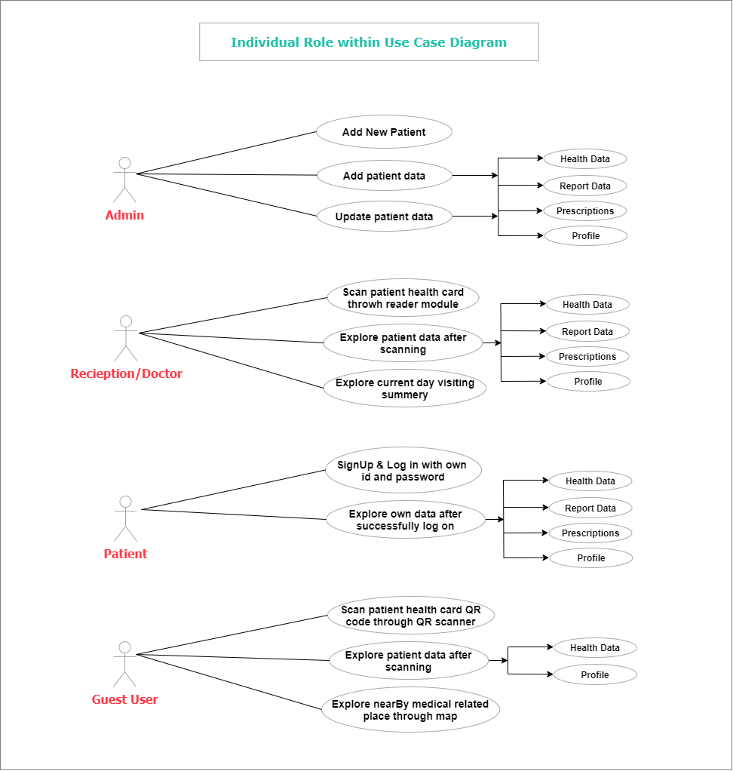

Figure 3.1.2: System Use case Diagram

Here we also care about security issues one can’t easily access others sensitive information only emergency information will be shown. Only doctor can update health related information and reports systemically. Hospital representative can add a patient and explore his information by scanning his health card. A guest user may have a quick go through to our system apps and find out location of nearby hospital or pharmacy but he doesn’t have access to others information in case of security reason he has to be a registered member.

### **System Architecture**

A system architecture is the [conceptual model](https://en.wikipedia.org/wiki/Conceptual_model) that defines the [structure](https://en.wikipedia.org/wiki/Structure), [behavior](https://en.wikipedia.org/wiki/Behavior), and more [views](https://en.wikipedia.org/wiki/View_model) of a [system](https://en.wikipedia.org/wiki/System).  An architecture description is a formal description and representation of a system, organized in a way that supports reasoning about the [structures](https://en.wikipedia.org/wiki/Structure) and [behaviors](https://en.wikipedia.org/wiki/Behavior) of the system.

A system architecture can consist of system [components](https://en.wikipedia.org/wiki/System) and the sub-systems developed, that will work together to implement the overall system. There have been efforts to formalize languages to describe system architecture, collectively these are called [architecture description languages](https://en.wikipedia.org/wiki/Architecture_description_languages) (ADLs)

In this section, we describe the system architecture of IOT Based Personal Health Card and License Management System which consists of Admin, Authentication, User, and Entrance Display within android and web application.

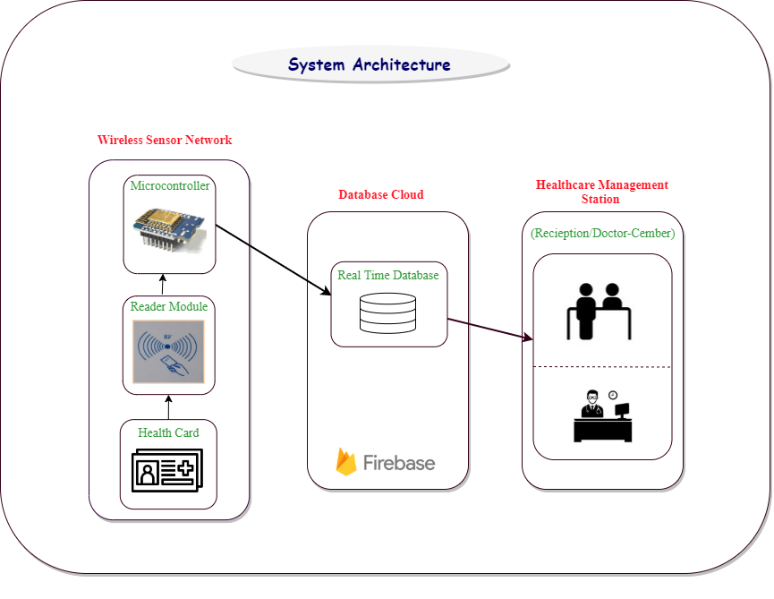

Figure 3.3.1: System Architecture

Here we use WeMos D1 mini ESP8266 as a micro controler and RFID card as a reader module we built a personal demo card [fig 3.2.1] which have some basic information like name , email, age, blood-group, phone number in its front side and there is a QR code on its back one can easily scanned this card and get the basic information of patient from our firebase database and get our service for free.All they need is just install our application even without registration one can get our services as a guest user.

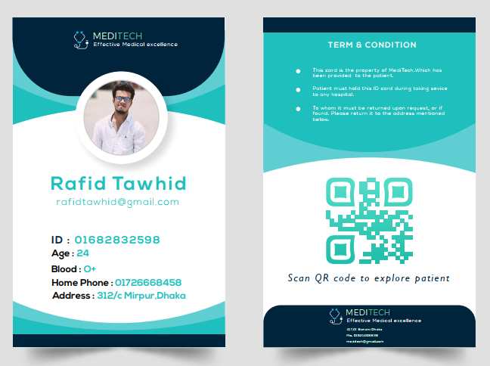

**Front Side**

**Back Side**

Fig : 3.3.2Health Card Demo

### **Pin Definition**

In the Figure 3.4.1, the pin definition of WeMOS D1 mini [8] is shown and in the Table 3.1 a detailed pin description is given.

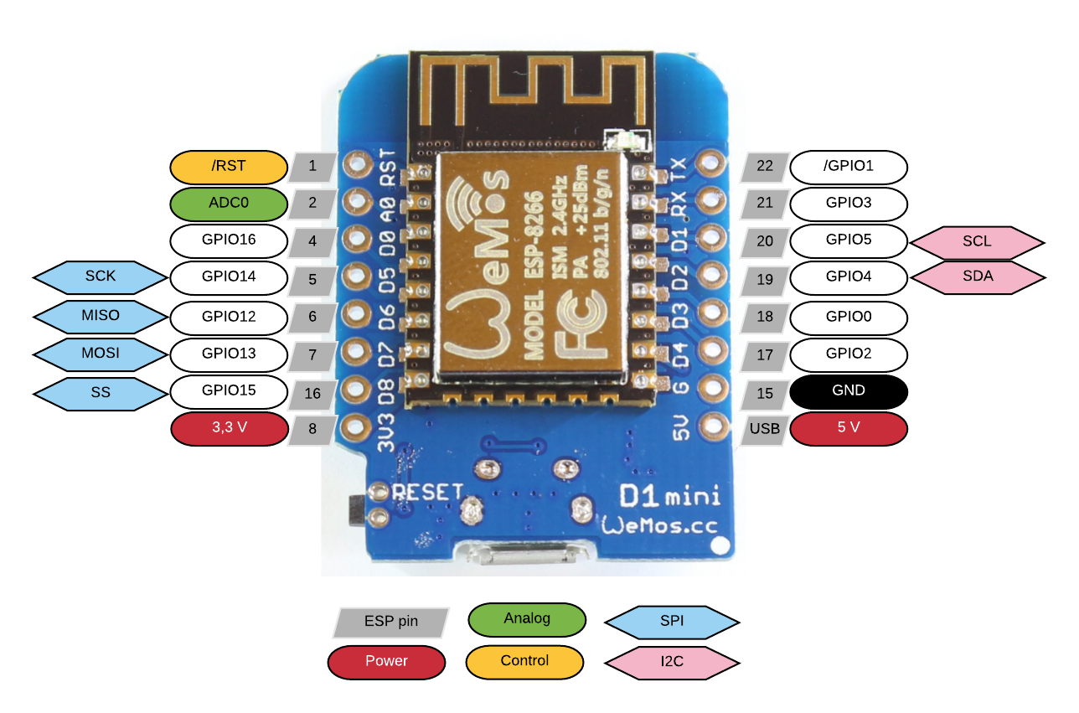

Figure 3.4.1 WeMos D1 mini ESP8266 pinout

## 3.5 Parameter

The NodeMCU parameters are listed in Table 3.2.

|  |  |  |
| --- | --- | --- |
| Categories | Items | Values |
| Wi-Fi Parameters | certificates | FCC/CE/TELEC/SRRC |
| WiFi Protocols | 802.11 b/g/n |
| Frequency Range | 2.4G-2.5G (2400M-2483.5M) |
| TX Power | 802.11 b: +20 dBm |
| 802.11 g: +17 dBm |
| 802.11 n: +14 dBm |
| RX Sensitivity | 802.11 b: -91 dbm |
| 802.11 g: -75 dbm (54 Mbps) |
| 802.11 n: -72 dbm (MCS7) |
| Types of Antenna | PCB Trace, External, IPEX Connector, Ceramic Chip |
| Hardware Parameters | TX Power | UART/SDIO/SPI/I2C/  I2S/IR Remote Control |
| GPIO/PWM |
| Operating Voltage | 3.0~3.6V |
| Operating Current | Average value: 80mA |
| Operating Temperature Range | -40°~125° |
| Ambient Temperature Range | Normal temperature |
| Package Size | 5x5mm |
| External Interface | N/A |

Table .5.1: Parameters of WeMOS D1 mini

In the Figure 3.2, the pin definition of RFID MFRC522 [8] is shown and in the Table 3.3 a detailed pin description is given.

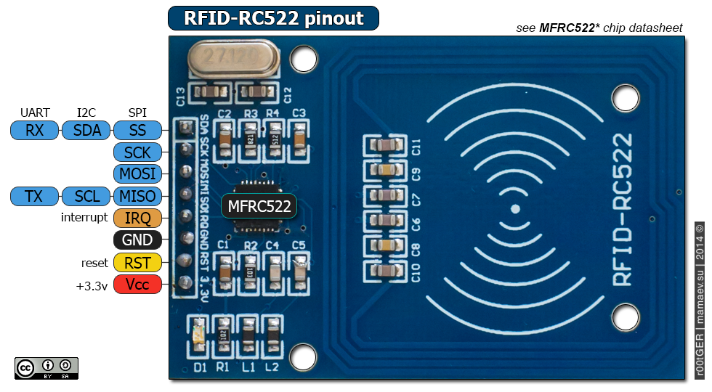

Figure 3.2 RFID MFRC522 pinout

Table .3: Parameters of WeMOS D1 mini

|  |  |  |
| --- | --- | --- |
| **Pin Number** | **Pin Name** | **Description** |
| 1 | Vcc | Used to Power the module, typically 3.3V is used |
| 2 | RST | Reset pin – used to reset or power down the module |
| 3 | Ground | Connected to Ground of system |
| 4 | IRQ | Interrupt pin – used to wake up the module when a device comes into range |
| 5 | MISO/SCL/Tx | MISO pin when used for SPI communication, acts as SCL for I2c and Tx for UART. |
| 6 | MOSI | Master out slave in pin for SPI communication |
| 7 | SCK | Serial Clock pin – used to provide clock source |
| 8 | SS/SDA/Rx | Acts as Serial input (SS) for SPI communication, SDA for IIC and Rx during UART |

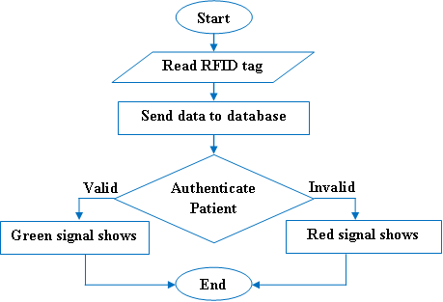

Figure 4.1.2 Patient Authentication using RFID [System Design]

* 1. ***Database Schema***

The core part of system module contains patient maintenance data schema is explained bellow and referred to this schema we tell about whole process of the system overview within several parameter.

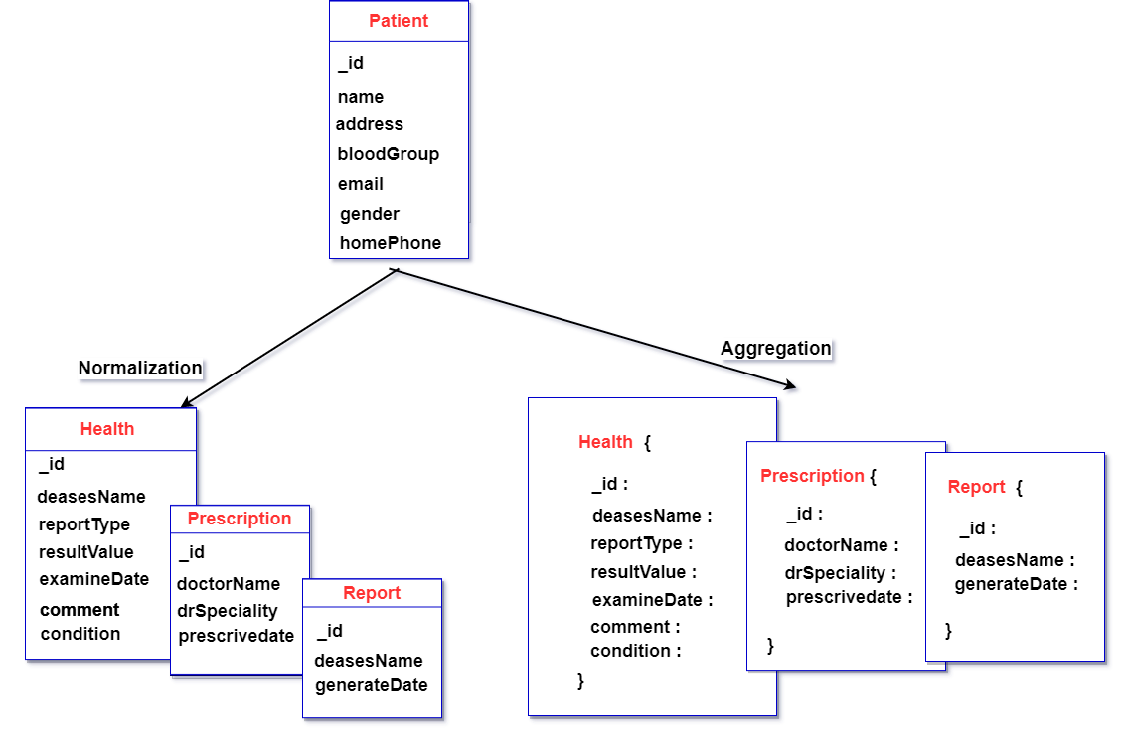

**Figure: 4. 5.1 Database Scheme**

A database schema is the skeleton structure that represents the logical view of the entire database. It defines how the data is organized and how the relations among them are associated. It formulates all the constraints that are to be applied on the data.

Here in the term of patient we have some attributes like id, name, address, blood group, email, gender, homepage & we also have two categories schema Normalization and Aggregation .In Normalization we have Health, prescription & reports of a patients with their attribute like a skeleton structure that represents the logical view of the entire database. On the other hand aggregation also has those attributes but in a organized way with associated relations among them.

* 1. ***Class Diagram***

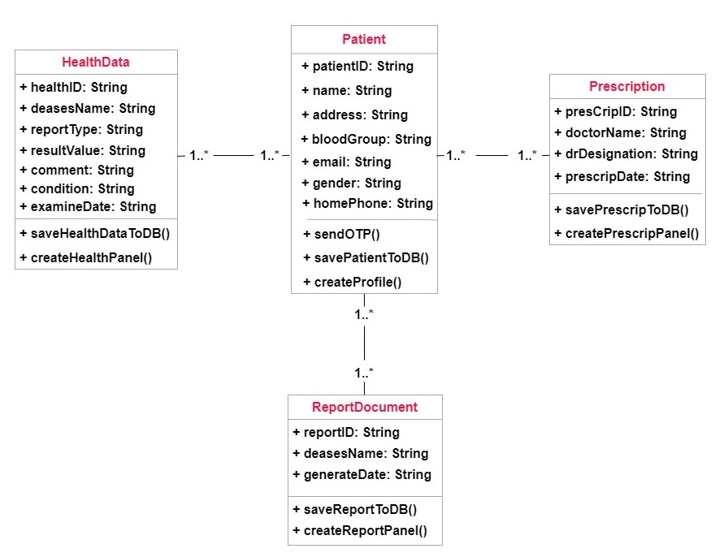

Figure 3.6.1 Class Diagram

In [software engineering](https://en.wikipedia.org/wiki/Software_engineering), a class diagram in the [Unified Modeling Language](https://en.wikipedia.org/wiki/Unified_Modeling_Language) (UML) is a type of static structure diagram that describes the structure of a system by showing the system's [classes](https://en.wikipedia.org/wiki/Class_(computer_science)), their attributes, operations (or methods), and the relationships among objects.

In figure 4.2 we state the relations and dependency of patients with his data, prescription and reports. Here patient has some attributes with some classes all those things are inter-related with His health data and its attributes with classes. Just like this reports and prescriptions are also inter-related with patient.

***3.7 Working Flowchart***

**

Figure 4.1.2 Flow Chart

## The process flow will start after reading the RFID tag after reading it will send the data to database if all required data are valid then the process will continue next step and the services will start but if required data are not valid then the process will end with an error message and won’t move to the next step.

## Chapter Summary

In this chapter, ...

# Implementation

4.1 System Modules

The **database schema** of a [database](https://en.wikipedia.org/wiki/Database) is its structure described in a [formal language](https://en.wikipedia.org/wiki/Formal_language) supported by the [database management system](https://en.wikipedia.org/wiki/Database_management_system) (DBMS). The term "[schema](https://en.wiktionary.org/wiki/schema)" refers to the organization of data as a blueprint of how the database is constructed (divided into database tables in the case of [relational databases](https://en.wikipedia.org/wiki/Relational_databases)) [figure :3.5.1] . The formal definition of a [database](https://en.wikipedia.org/wiki/Database) schema is a set of formulas (sentences) called [integrity constraints](https://en.wikipedia.org/wiki/Integrity_constraints) imposed on a database. These integrity constraints ensure compatibility between parts of the schema. All constraints are expressible in the same language. A database can be considered a structure in realization of the [database language](https://en.wikipedia.org/wiki/Database_language). The states of a created [conceptual schema](https://en.wikipedia.org/wiki/Conceptual_schema) are transformed into an explicit mapping, the database schema. This describes how real-world entities are [modeled](https://en.wikipedia.org/wiki/Data_modeling) in the database.

A database generally stores its schema in a [data dictionary](https://en.wikipedia.org/wiki/Data_dictionary). Although a schema is defined in text database language, the term is often used to refer to a graphical depiction of the database structure. In other words, schema is the structure of the database that defines the objects in the database

The Firebase Realtime Database is a cloud-hosted database. Data is stored as JSON and synchronized in realtime to every connected client [figure :3.3.1]. When you build cross-platform apps with our iOS, Android, and JavaScript SDKs, all of your clients share one Realtime Database instance and automatically receive updates with the newest data.

* 1. App Design

Design should organize the user interface purposefully, in meaningful and useful ways based on clear, consistent models that are apparent and recognizable to users, putting related things together and separating unrelated things, differentiating dissimilar things and making similar things resemble one another. The structure principle is concerned with overall user interface architecture.

The design should make simple, common tasks easy, communicating clearly and simply in the user’s own language, and providing good shortcuts that are meaningfully related to longer procedures.

The design should be flexible and tolerant, reducing the cost of mistakes and misuse by allowing undoing and redoing, while also preventing errors wherever possible by tolerating varied inputs and sequences and by interpreting all reasonable actions.

## Admin

Already we define role of admin several time, where by admin able to add new patient by adding patient phone no as patients ID after verification (By sending OTP). Then filled up all patient personal information and necessary medical history. After registered, admin configured patient medical related data, such as current health info, report-documents, prescriptions, and profile panel. The role of admin methods are define bellow.

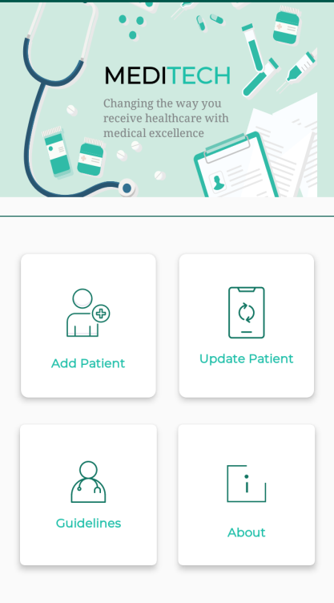 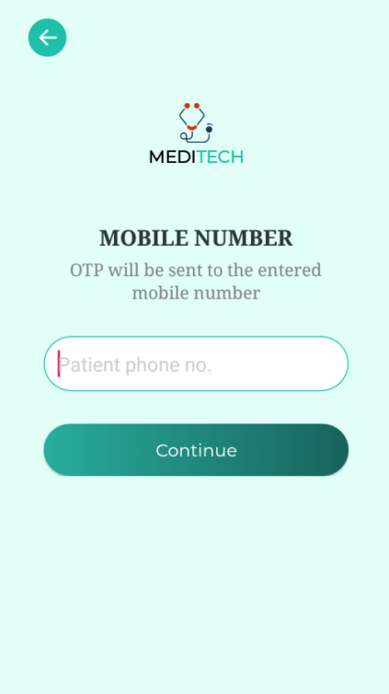

Figure 4.1.2 Entered patient phone no

Figure 4.1.1 admin dashboard

Here (figure 4.1.1) admin can add any user manually or one can create an account through his Mobile number and other information an OTP (one-time password) is send to confirm the Mobile number and other information.

Only admin can sign-up for a user through verification this is for security reasons and reducing the complication if any user can sign-up online by his own it will be difficult to serve and organize the whole system. Our system will serve only the authentic patient verified from any hospital or doctor. And finally for the existence we use OTP confirmation for authenticate the users. Here cloud database meet up as bridge adapter within admin backend and system front end. The aim of the OTP authentication is, the user can’t be able to register for multiple accounts, as for each account a unique phone number is needed. When we have all the users verified by a phone number the value of your user base increases and fraud account avoided. Nowadays more people using apps and remembering passwords are a headache for many users, so they end up using weak passwords. Using phone authentication increases security and user experience, as the user does not need to create and remember passwords, they will enter their number and then they can receive a temporary authentication code by SMS. As security concern, Authentication using only a phone number, while convenient, is less secure than the other available methods, because possession of a phone number can be easily transferred between users. Also, on devices with multiple user profiles, any user that can receive SMS messages can sign in to an account using the device's phone number.

If we use phone number based sign-in in your app, you should offer it alongside more secure sign-in methods, and inform users of the security tradeoffs of using phone number sign-in.

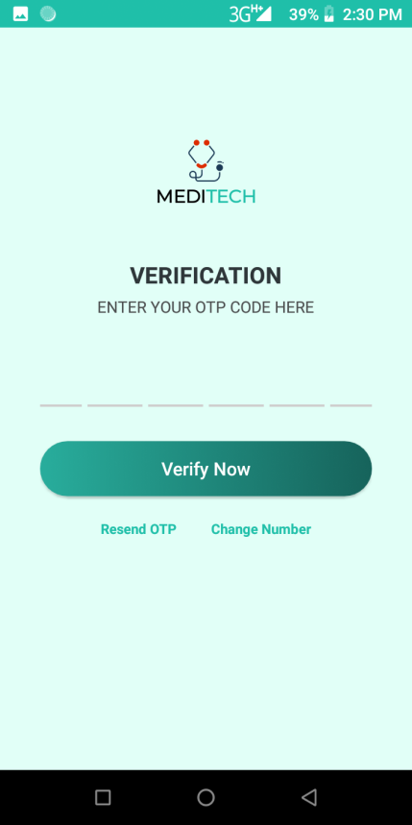 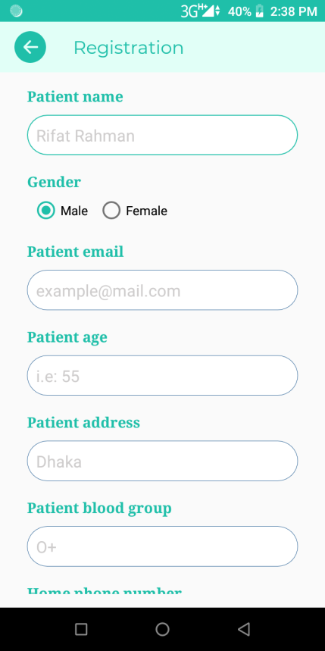

Figure 4.1.4 Register Patient

**Figure 4.1.3 Send OTP**

(Figure 4.1.3) user has to confirm his identity through giving the proper OTP code .Admin can add any user or update his information. Admin has the full access to set the guidelines and upgrade features. About panel has manufacturing and developer information.

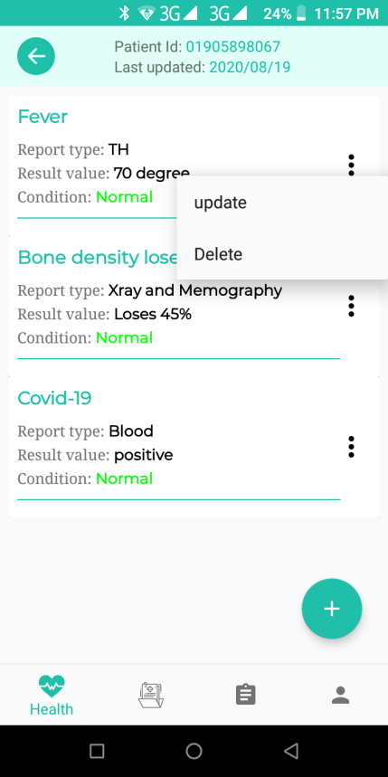 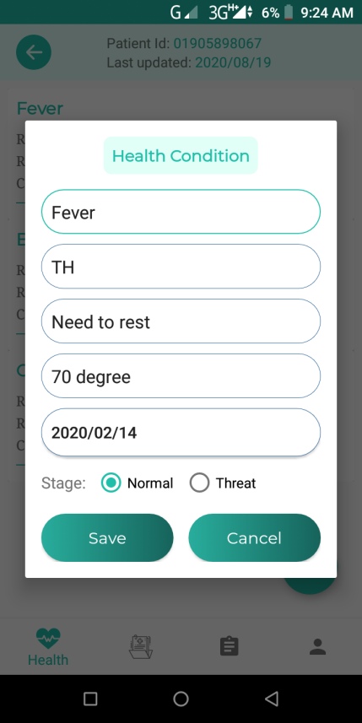

Figure 4.1.6 add/update data

Figure 4.1.5 Manipulate data

So, according to these criteria patient all about data manipulate and maintenance over the admin. Such a Health, Documents, Prescription, and profile information respectively within application. All of the data are hocked into cloud database.

Here Admin have access to one’s all information he can check and update the health info, personal info and other all necessary information which is necessary to maintain control over all the system. To upgrade the whole data admin panel has the highest priority access to all authentic information and backend side.

## Authentication (Wireless Sensor Network)

One of the core parts of the system is this. In this case healthcare institution able to identified valid patients more efficiently within patient’s health card. Moreover doctors able to explore patient’s previous medical records by scanning health cards. Medical records fetched from cloud database and current patients also sensing from real-time cloud data. Now the overall methodology behind this part presented bellow.

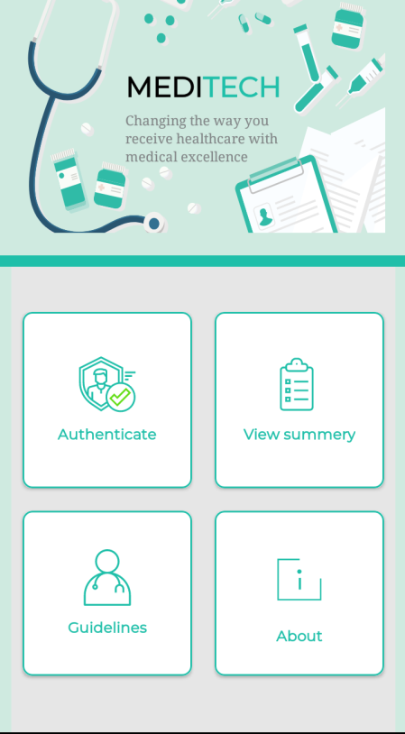 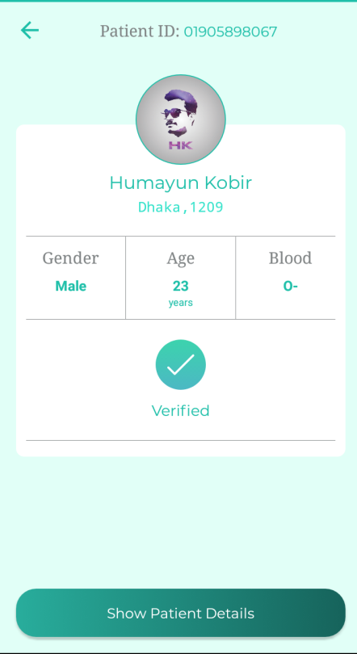

Figure 4.2.4 Health Card authentication Screen

Figure 4.2.3 Dashboard

In Figure 4.2.3 it is the dashboard of our patient and having a successful registration login. He may have the authentication information summary of his health conditions attribute like reports, prescription & instruction given by doctor. He also may read our rules and regulation of this system and proper guideline how to make the best use of our system. Figure 4.2.4 Is the face of our patient profile after the verification. There have only few basic things like gender, age , blood group nothing details yet.

## Users (Patients/Guest)

Here user role has been divided into two parts. Patients able to register themselves after admin authorized. Then patients able to explore all own medical records after sign in. On the other hand a guest user might be scan QR code (printed to health card) to find out patients current health condition and patients profile respectively. In this role also able to find out nearby emergency place according to rout and direction in order to help patients. They will have an own profile panel where he can find his dashboard panel (figure: 4.3.1), Where he can find his authentication information, his health summary, reports and own profile (figure: 4.3.2). he may get update of his health condition , he can see his reports & prescriptions authorised by verified doctors. Patient can see and download all reports and precripation if necessary. Then by the passage of time doctor will upgrade his health conditions patient may see his progress result. Patient can find the nearby hospitals and pharmacies location and root plan if necessary. In this case should be noted that a patient should be registered before sign in and he/she only able to might be registration if already authenticated by admin. So, during registration at first validate either valid patient.

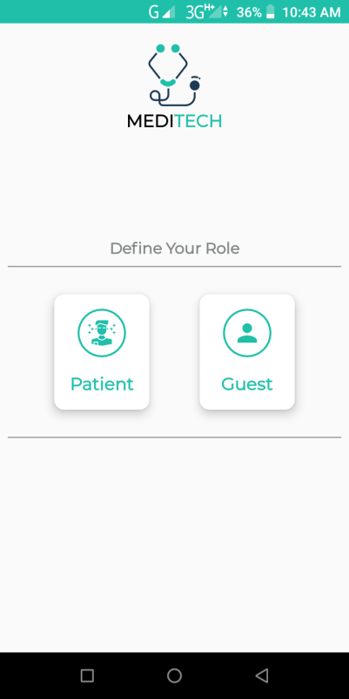 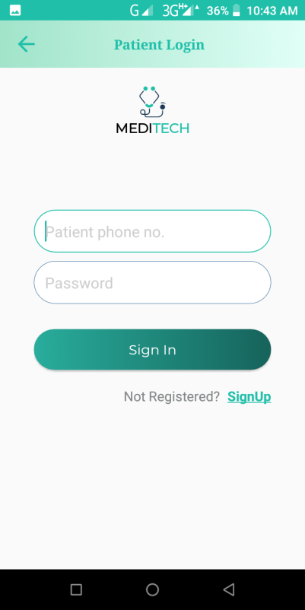

Figure 4.3.2 Patient Login

Figure 4.3.1 User Role Wrapper

We also have a dashboard panel for a guest or unregister users (figure 4.3.4) .Here one can scan the Health card (figure 4.3.5) of users and get nearby locations, our guideline and our system related information.

Here in signup no outsider is allowed only admin can register an user after completing his verification through his authentic information. But one can allow to checkout our system basic structure as a guest. No information and anything are needed to be a guest user you just have to install our system. On the other hand guest user couldn’t able to login or registration and view all the data of patient.

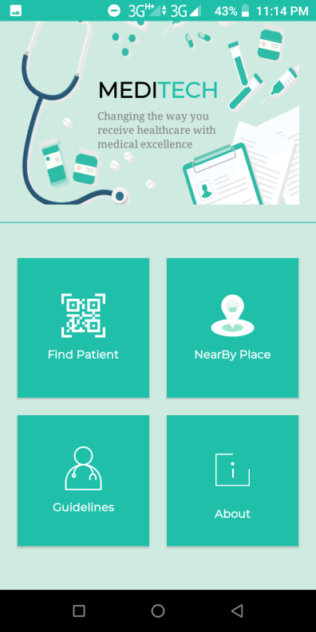 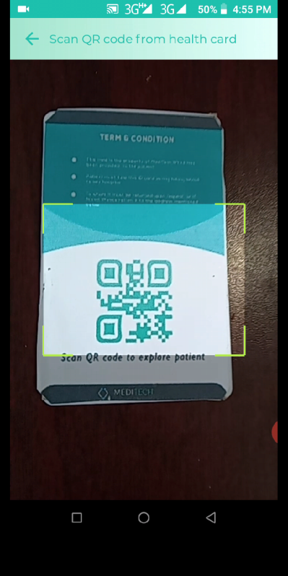

Figure 4.3.5 Scan patient health card

Figure 4.3.4 Guest Dash Board

Guest user can find the nearby hospitals and pharmacies location (figure 4.1.11) and root plan (figure 4.1.12) without being a register user which may help in case of emergency situation.

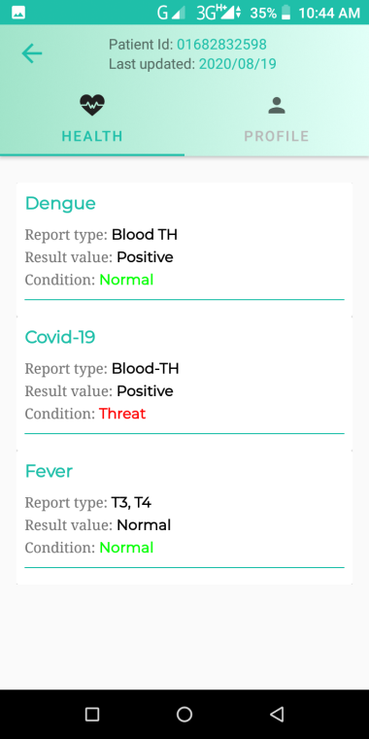 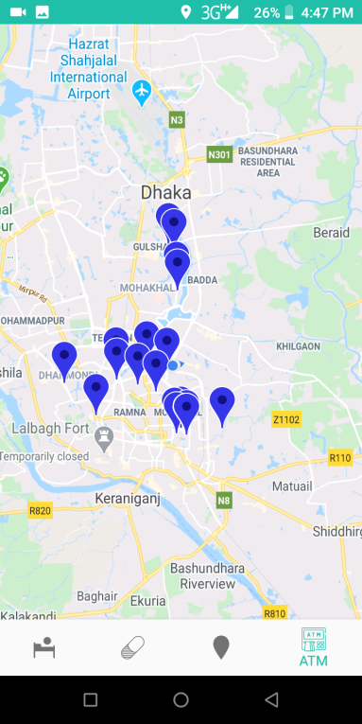

Figure 4.3.7 nearby emergency location

Figure 4.3.6 Patient Info

## foundPlace.png PlaceDirection.png

Figure 4.3.9 Explore direction

Figure 4.3.8 Selected location

Introducing a simple way to add Google's rich, local information to your maps. This turnkey solution lets you show accurate details for nearby places, so users can see ratings, reviews, photos, and directions without ever leaving your web app. Plus, you can customize it to match your brand.

User can give his feedback as expectations in [figure 4.3.8] one can rate the hospital after being served as like Google map rating. One can easily find out the root plan and exploring around without any complication.

The Places API is a service that returns information about places using HTTP requests. Places are defined within this API as establishments, geographic locations, or prominent points of interest.

Each of the services is accessed as an HTTP request, and returns either an JSON or XML response. All requests to a Places service must use the https:// protocol, and include an API key.

The Places API uses a place ID to uniquely identify a place. For details about the format and usage of this identifier across the Places API and other APIs, see the [Place IDs](https://developers.google.com/places/web-service/place-id) documentation.

4.3 IoT-Implementation

Our intent in this document is to identify the issues we ran into while creating this project, the answers and solutions we discovered and some of the customizations we tried

The next step for this project is building the peripheral hardware to extend the Node MCU & RFID into a target Android Things IoT device. The system where Android Things First Device app will interact with this device. While the peripheral hardware is a **very** simple circuit it was obvious to us. We were going to need to do some research to come up to speed on how to build this circuit

The following electronic components are needed for the First Device project:

* .Breadboard
* Jumper wires
* LED
* Node- MCU
* Resistors:
  + 1 - 470 ohm
  + 1 - 10K ohm

Additional recommended parts:

* GPIO Breakout Board
* Ribbon cable

The peripheral hardware for the First Device, as defined in the [Connect the Hardware](https://developer.android.com/things/training/first-device/connect-hardware.html) section of the Android Things documentation, is two distinct ciruits RFID Module and Node-MCU. one circuit for provide information input and a second circuit for Analysise the input with firebase data and giving the proper feedback. This wasn’t immediately apparent to us. Once we understood there were two separate ciruits involved the peripheral hardware layout and the app code made sense.

The Android Things documentation shows the layout for a generic Android Things hardware platform connected to a breadboard with both the button and LED circuits. In the following sections We have broken down the two circuits individually as well as the final combined circuit configuration.

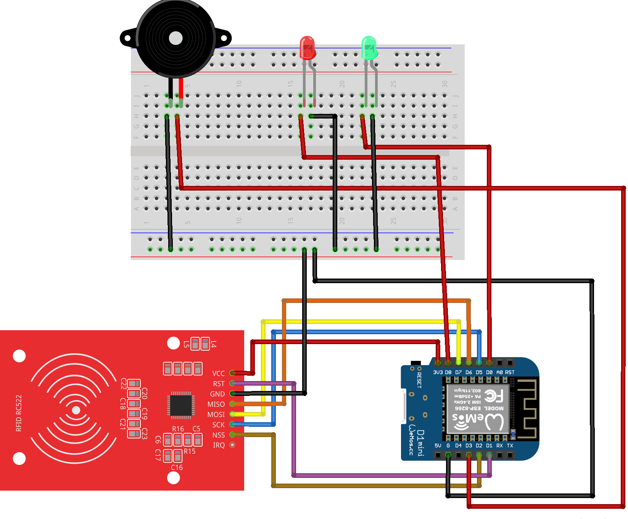

Figure 4.2.1 Circuit Diagram (WSN) [IoT device]

## Chapter Summary

In this chapter, ...

# Conclusion

Conclusion text here ...

## Limitations

...

## Future Work

...

# References

1. Kohn, L.T., Corrigan, J.M., Donaldson, M.S.: To Err Is Human: Building a Safer Health System. The National Academies Press (2000), <http://www.nap.edu/openbook.php?record_id=9728>
2. Preventable Medical Errors – The Sixth Biggest Killer in America, American Association for Justice, <http://www.justice.org/cps/rde/justice/hs.xsl/8677.htm>
3. H. G. Inc., Patient Safety in American Hospitals (2004), <http://www.healthgrades.com/media/english/pdf/> HG Patient Safety Study Final.pdf
4. Claudia Hildebrand, “Current state and future of health smart cards in Europe”, German Research Center for Environmental Health, available at <http://www.hscf.net/029esemenyek/029_281007eugy_ea/Electronic_Health_Cards_in_Europe.pdf>
5. Roberti, M.: Does RFID Create Negative Effects in Hospitals? RFID Journal (2008), <http://www.rfidjournal.com/article/view/5264>
6. Moessner, M., Khan, G.N.: Secure authentication scheme for passive C1G2 RFID tags. Computer Networks 56(1), 273–286 (2012)
7. Ngai, E. W. T., Cheng, T. C. E., Au, S., & Lai, K. H. (2007a). Mobile  
   commerce integrated with RFID technology in a container depot.  
   Decision Support Systems, 43, 62–76
8. Swedberg, C. (2006). Crown saves manufacturing costs via RFID.  
   RFID Journal. Retrieved November 10, 2006, from http://www.  
   rfidjournal.com/article/articleprint/2810/-1/1
9. Ericson, J. (2004). RFID for hospital care. E-business Executive Daily.  
   Fisher, J. A., & Monahan, T. (2008). Tracking the social dimensions  
   of RFID systems in hospitals. International Journal of Medical  
   Informatics, 77, 176–183

# 

Dayyala Sunitha, D.SreeHari. (November 2015). RFID Based Accident Avoidance System Using MEMS and GSM. *International Journal of Science, Engineering and Technology Research (IJSETR)*, Volume 4, Issue 11.

J.J. Santana, J. E. (august 23/26/2007). Health Care Applications Based on Mobile Phone Centric Smart Sensor Network . *Conference of the IEEE EMBS Cité Internationale, Lyon,* (p. 6298). France: IEEE.

Tudor Ioan CERLINCA, C. T. (05 August 2014). RFID-based Information System for Patients and Medical Staff Identification and Tracking . *Cristina Turcu.* Stefan cel Mare University of Suceava Romania .